**Weekly Assignment 8 - Usability Scavenger Hunt**

First of all, I will compare the mapping of the two products. I would like to compare iPhone’s operating system to Microsoft's Lumia.

1A good use of mapping: iPhone OS

Interface and appearance of various APP ICONS. IOS actually has a simple and beautiful interface and APP icon and attracts a lot of users. From the original iPhone, the latest iPhone X, IOS interface has changed, from control center to custom function and notification center, more and more personalized experience mode and more and more efficient operation methods. Getting users to use their phones is a great pleasure. Thanks to the simple interface, both the old and the young can quickly become adept at using the iPhone.

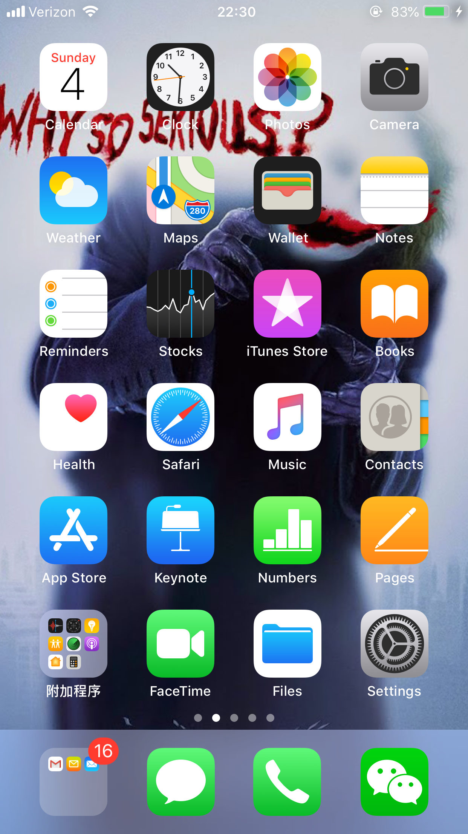

1B confusing mapping: Lumia’s operating system

Although Windows phones have a rich interface, they are very complex and difficult for new users. Windows phone, by contrast, is not as easy to use as the iPhone.

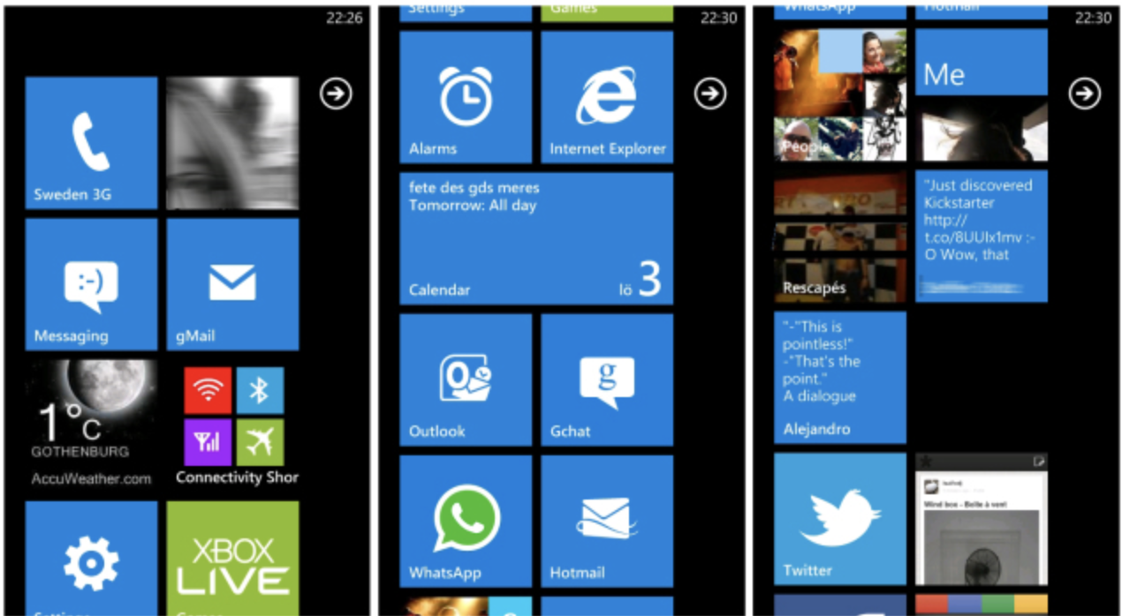

2A good use of affordance: As we known, the visibility refers to an attribute of an object that allows people to know how to use it. The Window operating system of computer is very good example of affordance.

Windows Server system is very easy to use compared with other Server systems, which greatly reduces the learning cost of users.

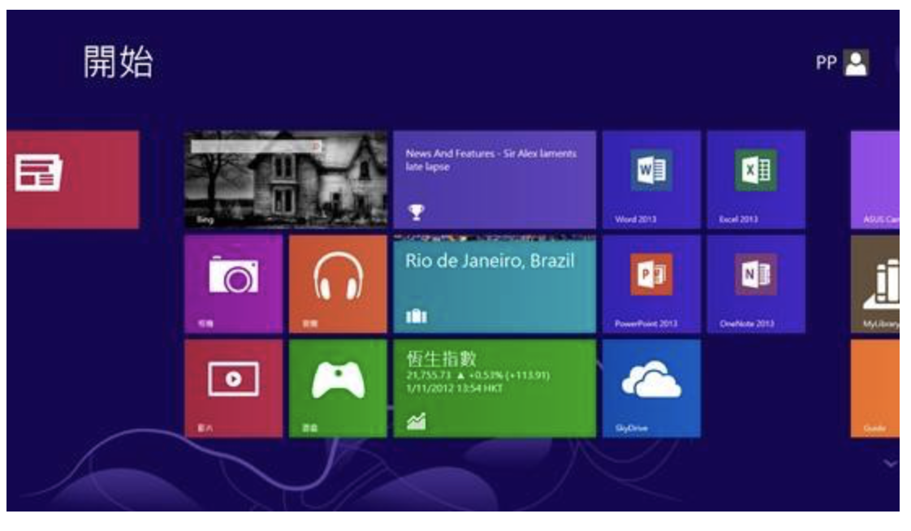

2B confusing affordance: Linux system

For the average person, operating a Linux system takes time to learn because they don't have enough computer knowledge



3A good use of constraint:

The iPad is very good example of constraint. Nowadays, we can see more and more iPad users, whether five or six years old or the elderly, can freely use the iPad to get what they want to know. The simple and convenient interface is similar to that of the iPhone.

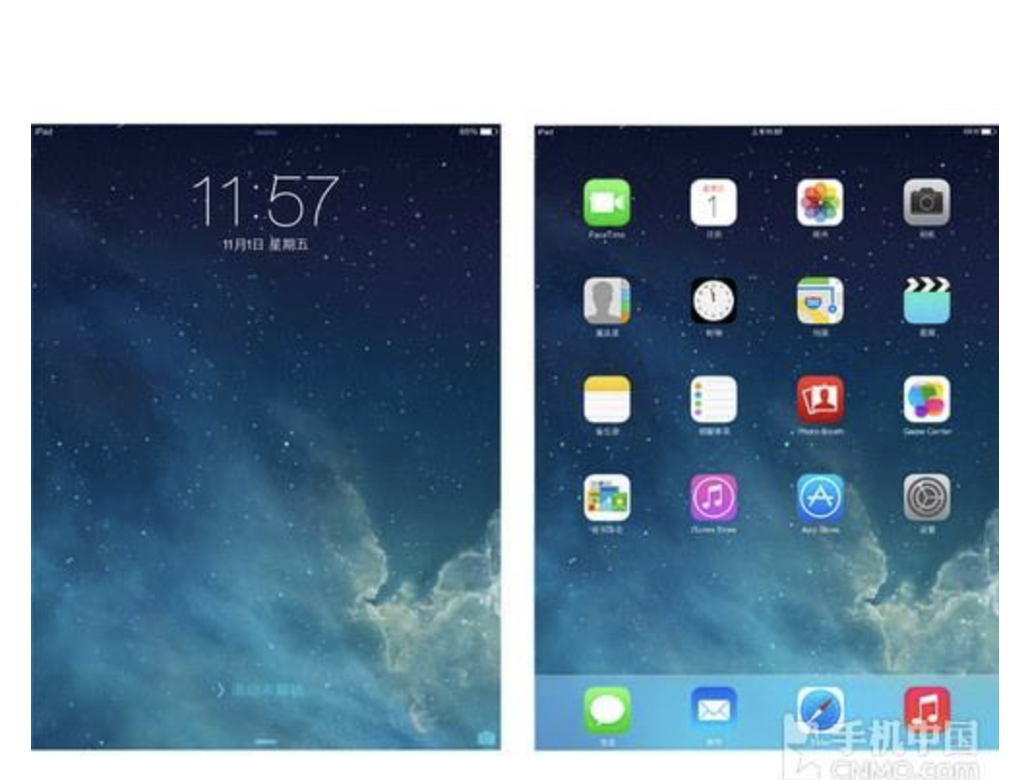

3B poor constraint: Android tablets are very restrictive, and for kids, because Android is open, a lot of kids download a lot of bad apps. For the elderly, the system is open and confusing.

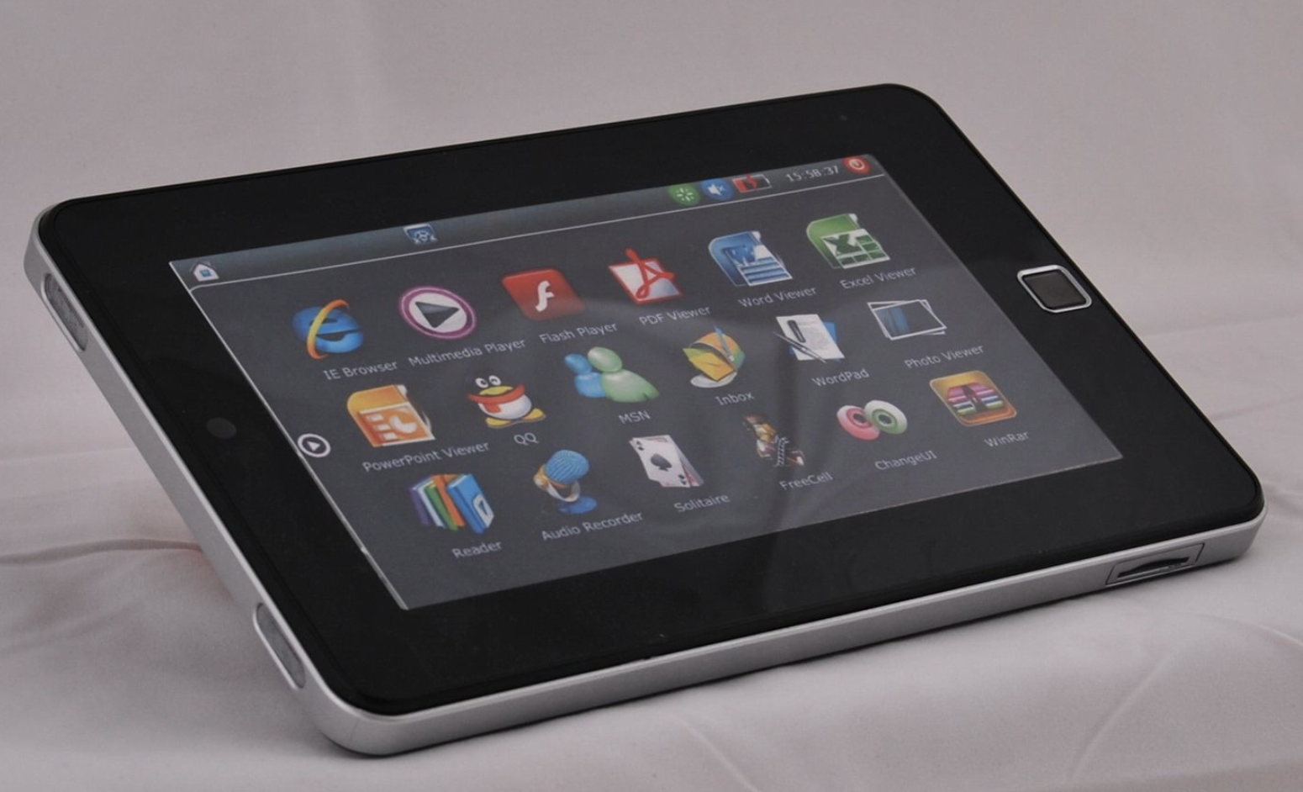

4A good use of feedback: Amazon is a great example of someone who takes full advantage of feedback and then makes changes to products based on customer recommendations and solutions. Even reviews from third-party sellers

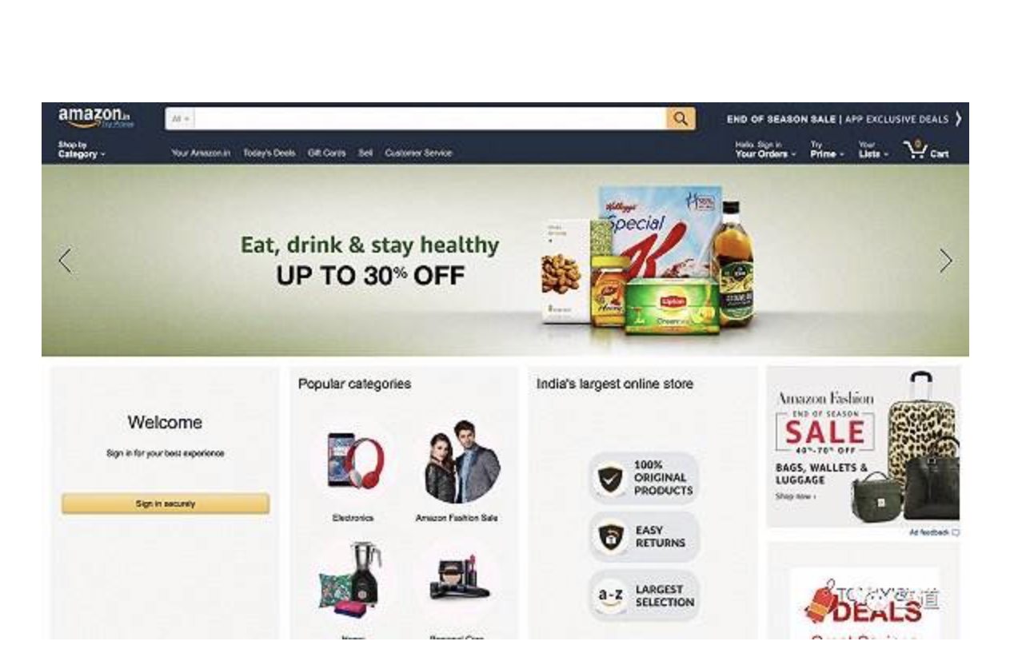

4B poor use of feedback: Taobao

Taobao, on the other hand, cannot do what amazon does.